Design Document - Task Distribution System : Batch-3

Team -  
Vaibhav Gehani  
Sachin Vaze  
Hitika Ailani  
Deepa Binnal  
Anjali Chaudhary  
  
***System Diagram***

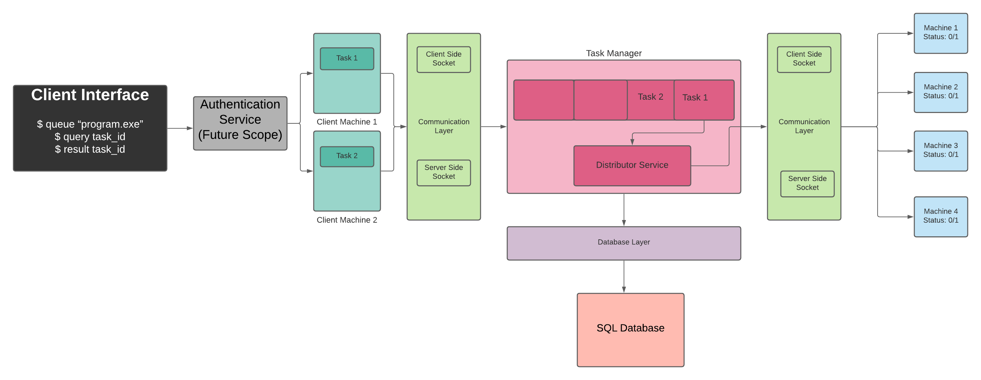

**Flow Diagrams:**

Project flow diagrams are drawn by considering the **type of requests** from clients.

* **Client request to queue a task**

* **Manager sending a task to execute on a Node**

* **Client request to get Status/Result for the given task ID**

**Sequence Diagram (Data Flow) :**

Client machine will be sending Tasks to the Task Manager and later Task manager will push the task to the queue. Now task will be assigned to the node for executing the required task. Once Task is being executed, its result is being updated to the database and task status needs to be updated in the database as well.

Commands can be executed in 3 ways: -

1. Client sending task to Task Manager. (**$ queue “program.exe”**)
2. Assigning task from queue to Node and Checking the status. (**$ query task_id**)
3. Task execution by Node and updating result to the Database. (**$ result task_id**)

In the above case, Queue and Database managing operations are managed by the Task Manager and Nodes will be running on the ports available on the machine. Data will be shared across the components using socket programming.

**Class Diagram:**

**Database - Relational Tables:**

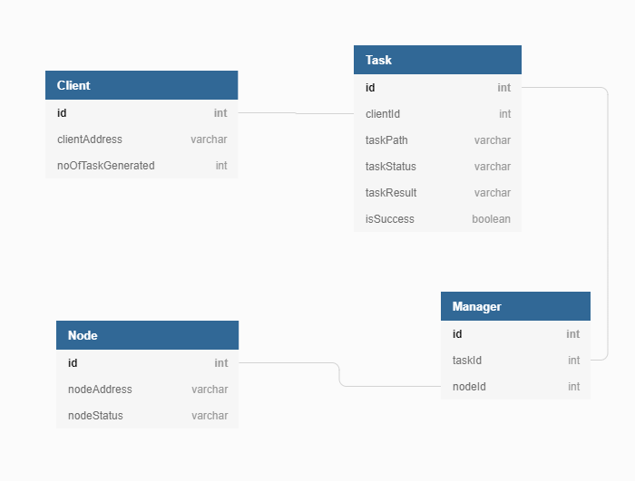

**Communication Layer:**

